Chemistry 115 Name Key

Dr. Cary Willard
Exam 1C February 23, 2009

 | Points Earned | Points Possible
Part 1  multiple choice |  | 30
Part 2  nomenclature |  | 10
Page 3 |  | 28
Page 4 |  | 18
Page 5 |  | 14
Total |  | 100

Note: All work must be shown to receive credit. On calculation problems show answer with the correct number of significant figures using scientific notation if necessary.
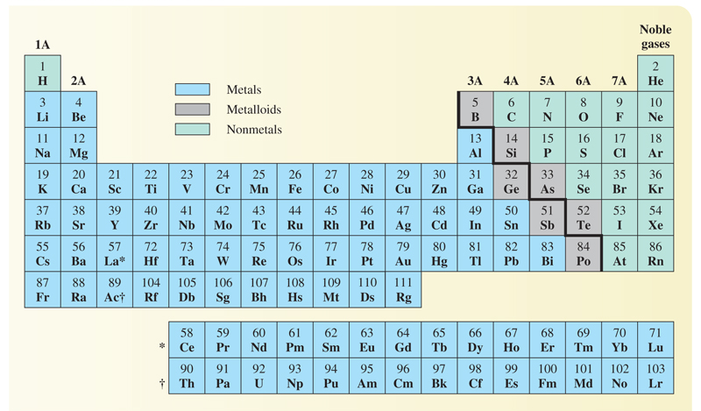

Part 1 – Multiple Choice (30 points)

- Why study chemistry?
  - To help us learn a technique for identifying and solving problems
  - To understand the behavior of materials
  - To help inform us about our world
  - To be better able to make informed decisions
  - All the above

- Which is a scientific observation?
  - Water freezes at zero degrees C
  - Freezing and boiling are called physical changes
  - If a substance has a density of 1.00g/mL it must be water.
  - When a substance freezes its molecules lose potential energy.
  - All of the above are scientific observations

- A well established hypothesis is often called a(n)

  - observation
  - fact
  - law
  - theory

- Which is a pure substance?

  - sugar
  - coffee
  - orange juice
  - mud

- How many significant digits are in the number 1.30 X 10⁴?

  - 1
  - 2
  - 3
  - 4

- The number, 14.74999, when rounded to three digits is

  - 10.0
  - 14.7
  - 15.0
  - 14.8

- One kilometer is equal to

  - 1000m
  - 100m
  - 0.001m
  - 0.01m

- When expressed in proper scientific notation the number 0.000034 is

  - 3.4 X 10⁻⁵
  - 34 X 10⁻⁴
  - 3.4 X 10⁻⁴
  - 3.4 X 10⁴
  - 3.4 X 10⁵

- Which type of element has the following general properties: low melting point and density, lacks luster, poor conductor of heat and electricity, and brittle?

  - Transition element
  - Metal
  - Metalloid
  - Nonmetal

- The smallest particle of an element that can exist is called a(n)

  - Ferrule
  - Atom
  - Neutron
  - Electron
  - Proton

- How many atoms of hydrogen are present in one molecule of Al(H₂PO₄)₃?

  - 2
  - 3
  - 5
  - 6
  - 7

- Which chemical symbol is properly written?

  - Cu
  - ca
  - CO
  - CL

- The alkali metals are in group

  - 1A
  - 3A
  - 5A
  - 7A

- Which is not a physical property of water?
  - Water is colorless.
  - The density of water at 4º C is 1.00g/mL.
  - Water reacts with sodium metal to produce sodium hydroxide and hydrogen.
  - The freezing point of water is 0º Celsius.
  - All of the above are physical properties of water

- Hydrogen combines with oxygen to form water. If 1.67g of hydrogen combines with 13.33g of oxygen what mass of water will be produced?

  - 16.67g
  - 13.33g
  - 15.00g
  - 11.66g
  - 1.67g

Part 2 – Nomenclature (10 points)

Fill in the following chart with the correct name or formula for the following elements and compounds.

Compound / Element Name | Formula / Elemental Symbol
Phosphorous | P
Fluorine | F
Boron | B
Silver | Ag
Zinc oxide | ZnO
Cupric chloride | CuCl₂
Sulfur diiodide | SI₂
Nitrogen tribromide | NBr₃
Vanadium(IV) sulfide | VS₂
Sodium phosphide | Na₃P

Part 3 – Problems and Questions (60 points)

- (6 points) Evaluate each of the following expressions. State the answer to the proper number of significant figures.

  - 32.353 + 3.98 + 255.33 = 291.66 or 2.9166 ×10³

  - $\frac{0.000625}{21.588}=2.90×{10}^{-5}$

- (8 points) Complete the following metric conversions using the correct number of significant figures. Put the answer in correct scientific notation.
  - 6.31 kg to mg

$$?mg=6.31 kg×\frac{1000 g}{1 kg}×\frac{1000 mg}{1 g}=6.31 ×{10}^{6}mg$$

  - 50.3 km to m

$$?m=50.3 km×\frac{1000 m}{1 km}=5.03×{10}^{4}m$$

- (8 points) Complete the following American / metric conversions using the correct number of significant figures
  - 0.385 m to in

$$?in=0.385 m×\frac{100 cm}{1m}×\frac{1 in}{2.54 cm}=15.1 in$$

  - 4.81 qt to mL

$$?mL=4.81 qt×\frac{946 mL}{1 qt}=4.55×{10}^{3}mL$$

- (6 points) Complete the following temperature conversion
52 ºC to ºF

$$℉=\left(52℃×\frac{180℉}{100℃}\right)+32℉=126℉$$

- (6 points) After you have worked out at the gym on a stationary bike for 45 minutes, the distance gauge indicates that you have traveled 14.5 miles. What was your rate in km/hr (5280 ft = 1 mile)

$$?\frac{km}{hr}=\frac{14.5 mi}{45 min}×\frac{60 min}{1 hr}×\frac{5280 ft}{1 mi}×\frac{12 in}{1 ft}×\frac{2.54 cm}{1 in}=\frac{3.11×{10}^{6}km}{hr}$$

- (6 points) Iron has a density of 7.87 g/mL. If 93.4 g of iron is added to 75.0 mL of water in a graduated cylinder, to what volume reading will the water level in the cylinder rise?

$$volume in graduated cylinder=75.0 mL+11.9 mL=86.9 mL$$

What is the volume of the iron? (Hint: Do this part 1st)

$$?volume iron=93.4 g iron×\frac{1 mL iron}{7.87 g iron}=11.9 mL iron$$

- (6 points) A personal trainer uses calipers on a client to determine his percent body fat. After taking the necessary measurements, the personal trainer determines that the client’s body contains 12.5% fat by mass. If the client weighs 115 kg, how many kg of fat does he have?

$$?kg fat=115 kg ×\frac{12.5 kg fat}{100 kg}=14.4 kg fat$$

- (8 points) Give definitions for the terms pure substance and mixture and give two examples of each type of material.

Pure substance – substance which is homogeneous throughout and can not be separated into simpler substances by physical means. Pure substances always have the same composition, regardless of where they are found or how they are made.
1. sugar
2. carbon
Mixture – substance which can be separated into individual substances by physical means. Different samples of a mixture may differ in composition.
1. gasoline
2. orange juice

- (6 points) Aqueous solutions of the substance nickel(II) sulfate are bright green in color. If an aqueous solution of barium chloride is added to an aqueous solution of nickel(II) sulfate, a white precipitate of barium sulfate forms. Based on the information in the previous paragraph, identify a physical and chemical property of nickel(II) sulfate.

Physical property

Bright green in color
Soluble in water

Chemical Property

Reacts with barium chloride to form a white precipitate of barium sulfate

